Name:
Your Age on Other Worlds http://www.exploratorium.edu/ronh/age/index.html
Directions: Go to the above internet site. Once you are at the site, you should read the “To Do & Notice” section and follow these directions. Make sure you remember to enter your birthdate as MM/DD/YYYY. Ask Miss Black for help if you do not understand this format.
After calculating your birthdate, fill in the following:
MERCURY  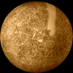  Your age is  Mercurian days  Mercurian years  Next Birthday | VENUS  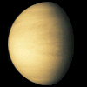  Your age is  Venusian days  Venusian years  Next Birthday | EARTH  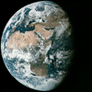  Your age is  Earth days  Earth years  Next Birthday

MARS  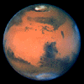  Your age is  Martian days  Martian years  Next Birthday | JUPITER  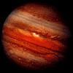  Your age is  Jovian days  Jovian years  Next Birthday | SATURN  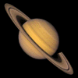  Your age is  Saturnian days  Saturnian years  Next Birthday

URANUS  Your age is  Uranian days  Uranian years  Next Birthday | NEPTUNE  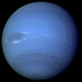  Your age is  Neptunian days  Neptunian years  Next Birthday | PLUTO  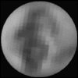  Your age is  Plutonian days  Plutonian years  Next Birthday
Answer the following questions:
- On which planet would your age be the least?
- On which planet would your age be the greatest?

When done exploring your weight, read the section titled “The Days (and Years) of Our Lives” towards the bottom of the page.

Your Weight on Other Worlds http://www.exploratorium.edu/ronh/weight/index.html
Directions: Go to the above internet site. Once you are at the site, you should read the “To Do & Notice” section and follow these directions.
After calculating your weight, fill in the following:

MERCURY  Your weight is | VENUS  Your weight is | THE MOON  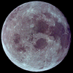  Your weight is | MARS  Your weight is

JUPITER  Your weight is | SATURN  Your weight is | URANUS  Your weight is | NEPTUNE  Your weight is

PLUTO
Your weight is

The Moons of Jupiter
IO  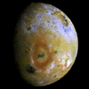  Your weight is | EUROPA  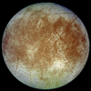  Your weight is | GANYMEDE  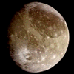  Your weight is | CALLISTO  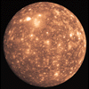  Your weight is

A Few Different Types of Stars
(better land at night to avoid burning your feet!)
THE SUN  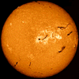  Your weight is | A WHITE DWARF  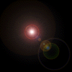  Your weight is | A NEUTRON STAR  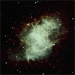  Your weight is

Answer the following questions:
- On which planet would your weight be the least?
- On which planet would your weight be the most?
- List the planets in order from the least amount of gravity to the most.
- On which object in space would your weight be the least?
- On which object in space would your weight be the most?
When done exploring your weight, read the section titled “What is Going On?” towards the bottom of the page.

