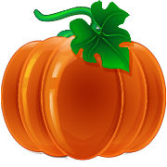
If I Were A Pumpkin...

If I were a pumpkin…
I would taste
I would be full of
I would like to
I’d want

If I were a pumpkin…
I would
I would wish
I would love
I would listen
I would

