Interactive Christmas Tree Using Scratch
- Open Scratch
- Delete Cat sprite
- Click Stage and click the backgrounds tab.
- Click Paint and draw a Christmas tree with a stand at the bottom of the trunk. 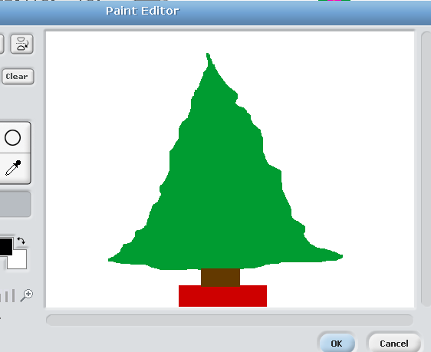
- Click ok.
- Click Paint a new sprite
- Draw a star, press the shrink button until it so it is small enough to fit on top of your tree. 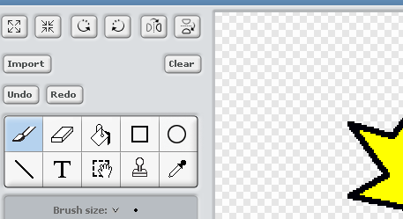
- Click Paint a new sprite.
- Draw a light bulb, shrink and press ok
- Draw and shrink as many ornaments as you would like. *Only draw one of each. For example- you do not need to draw multiple light bulbs. You can just duplicate the sprite later on.
- After you finish drawing all your light bulb, right click on it and “duplicate” it.
- 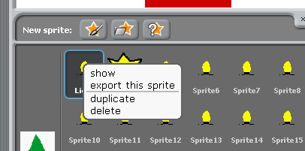 Duplicate your lights as many times you want them on your tree. Click and drag them on your tree.
- Do the same for your ornaments.
- Time for Scripts!-Make your lights and ornaments move and change colors!
- Here is an example: 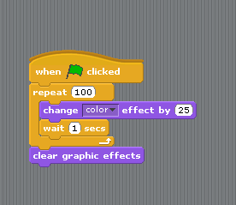
- If you want your lights to all change colors at the same time, make sure their scripts are exactly the same. Click the top block and drag the script on top of each light sprite.
- If you want them changing different colors then change the color effect number for each light sprite.
- You can do the same for the ornaments. Try to make them move as well! I used the “turn 15 degrees” block. Remember to use the wait block and negative numbers to make your sprite turn back to its original position!