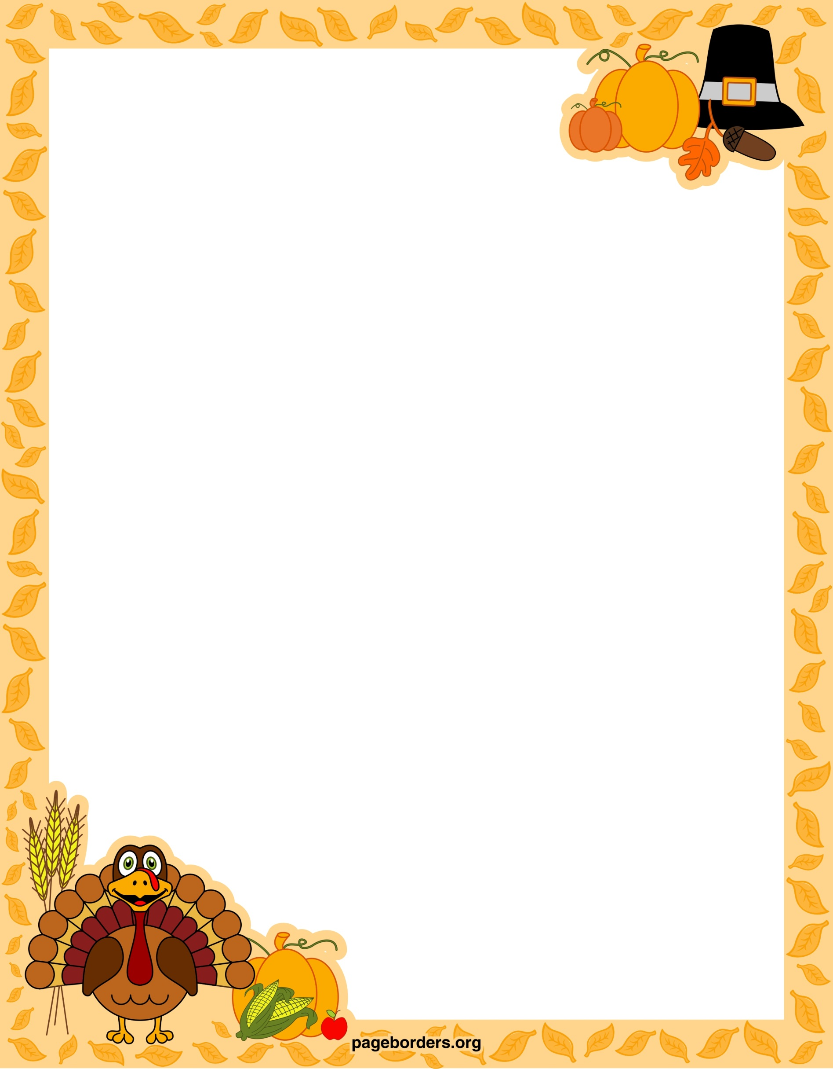

If I were a Thanksgiving Turkey...
I would look Click here to enter text.
I would listen Click here to enter text.
I would watch Click here to enter text.
I would want Click here to enter text.
If I were a Thanksgiving Turkey...
I would smell Click here to enter text.
I would taste Click here to enter text.
I would be stuffed with Click here to enter text.
I would wish Click here to enter text.
I would Click here to enter text.

By Click here to enter text.

