Name:

REMEMBER!

Short Hand is the HOUR hand

Long Hand is the MINUTE hand

Clocks

Using the arrows to make the analog clocks match the digital clocks.

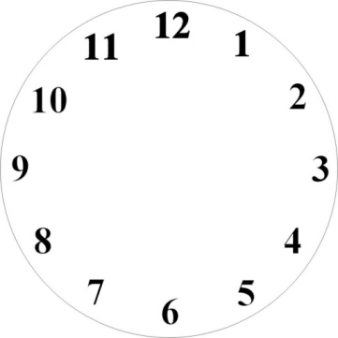

1:30

7:000



9:150



3:450








12:30

10:00

11:45

6:15

8:25

